**Hosting website from S3 with domain name from Godaddy**

Project Objective: You have an existing domain name purchased from Godaddy but would like to use AWS S3 to host it. To further enhance availability and implement SSL, can use CloudFront

Services used: S3, Route53

Step 1: Create your S3 bucket to share same name as your domain name (e.g. domain name is hustlersg.com)



Step 2: Create another S3 bucket with subdomain name



Step 3: For this subdomain bucket ([www.hustlersg.com](http://www.hustlersg.com)), upload your code (index.html, style.css etc)

Step 4: Enable static website hosting

Step 5: Under permissions tab add policy to enable access to the objects stored in your bucket.

Step 6: Return to the main domain bucket (hustlersg.com) and then enable static website hosting but choose redirect request instead

Step 7: Create AWS route 53 public hosted zone with same name as domain name

Step 8: In the newly created zone, there is one part for name servers (type: NS). Copy all 4 values to notepad

Step 9: Head on to Godaddy and under Domains > manage your domains > click on your domain name> Name servers > click on change Nameservers

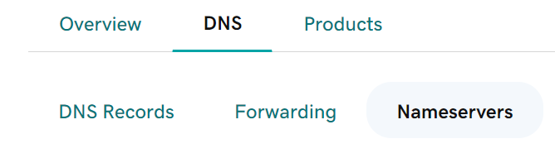

Step 10: Click on I’ll use my own nameservers > add the 4 values you copied from Route53 public hosted zone in and then click on Save.

Step 11: In Route53 create a record set for the main domain (hustlersg.com) and enable the Alias toggle > Route traffic to: Alias to S3 website endpoint > select the region your S3 bucket is in then select your main domain S3 bucket under “Enter S3 endpoint”

Step 12: Do the same for your sub domain (www.) and point it to your subdomain bucket

That’s it! Now you can try and access your website

Improvement: As S3 itself does not support https, we can use Cloudfront with ACM to host the site with https protocol.

Also, we can setup cache-control for the site.